1. Design DFA using simulator to accept strings in which a’s always appear tripled over input {a,b}

*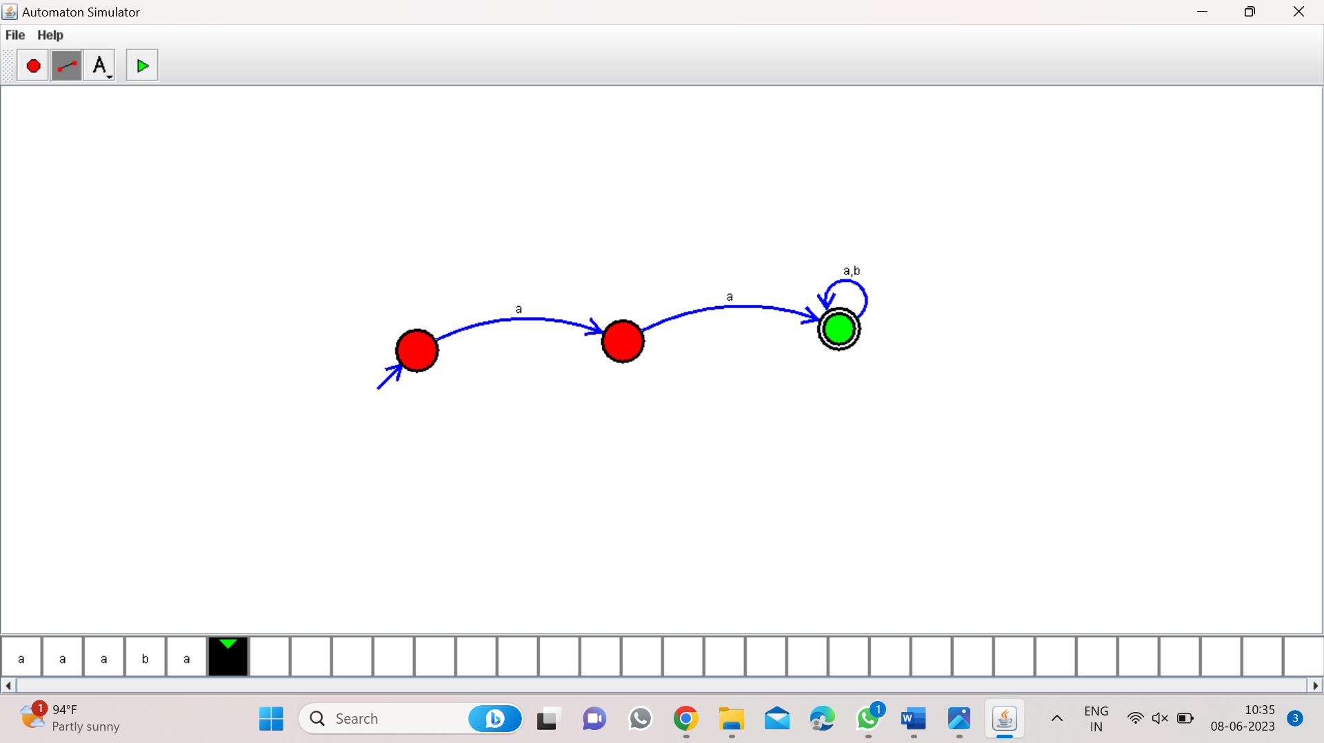*

*Result:-*

*From the above DFA diagram valid string in which a’s always tripled over input*